Together We Can - Building a Better Future for ‘Namgis People
RE-ELECT DONALD VICTOR ISAAC AS ‘NAMGIS CHIEF
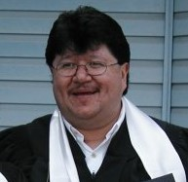

About the Candidate
Victor was first elected to ‘Namgis Council in 1980 when he was just nineteen years old. Before heading to university to pursue a degree in business administration. Victor served as a ‘Namgis Councilor for 20 years from 1980 to 2000.
After obtaining a degree from Simon Fraser University in Business Administration in 2006 Victor went to work with Indian and Northern Affairs Canada as a Funding Services Officer from 2006 to 2014 where he honed his skills and experience in sound fiscal management and governance. After retiring from the federal public service, Victor returned home to ‘Yalis and again served as a Councilor from 2014 to 2024 and then as ‘Namgis Chief from 2024 to 2026.
Victor would bring over 30 years of experience as an elected official and strong financial management skills to the role of Chief of the ‘Namgis Nation. He is committed to building a brighter future for our members. He strongly believes that “together we can build a better future for ‘Namgis people.” Donald Victor Isaac is seeking your vote to re-elect him as Chief of the ‘Namgis First Nation.

Platform

- ‘Namgis Title and Rights
We are the owners of the lands, waters and resources within our territory. Securing recognition of our ownership and jurisdiction over our lands, waters and resources is essential if we are to build a better future for ‘Namgis people. We can no longer sit by while others continue to exercise jurisdiction over and reap the benefits from our lands, waters and resources.

As a starting point, we need to secure recognition of our ownership, jurisdiction and control over our forest resources, our river, our lakes and the creeks in which our salmon spawn.

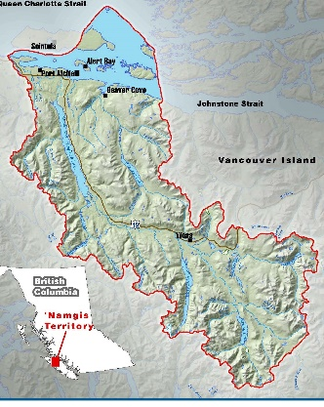
Our ancestors lived throughout the ‘Namgis valley for thousands of years. This is the heartland of our territory. As part of our title and rights strategy, we need to re-establish a ‘Namgis community or communities in our heartland.

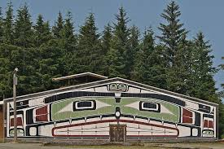
We need to move beyond governance under the Indian Act and secure recognition and implementation of our right to self-determination and self-government.

.
While being elected to office gives ‘Namgis Chief and Council a mandate to make decisions on behalf of ‘Namgis people over a range of subject matters, it cannot be left to ‘Namgis leadership alone to develop and implement strategies to protect, advance and secure recognition of our title, rights and jurisdictions over our lands, waters and resources. These rights are held collectively by all ‘Namgis people and all ‘Namgis people must have a say in how we move forward.
Under my leadership, I would work with ‘Namgis people, our hereditary Chiefs and ‘Namgis Council to develop strategies to protect, advance and secure recognition of our title, rights and jurisdiction over our territories and re-establish our presence throughout our traditional territory.

- Economic Strategy
The most effective economic strategy that we can pursue is to secure recognition of our title and jurisdiction over the lands, waters and resources within our territory. As we regain greater control and jurisdiction over our lands, waters and resources, we will be in a better position to effectively manage our economy and obtain the benefits of resource development in our territory.
In the past, as part of its economic and title and rights strategy, we leveraged our title and rights to enter into economic partnerships with industry in connection with the development of sand and gravel, forest and hydro resources. We have not fully leveraged our title and rights in relation to the development of forest resources within our territory.

Under my leadership, I would work with ‘Namgis Council, with support from our business development corporation, to pursue stronger economic partnerships with forest companies operating within our territory.
,
- Fishing

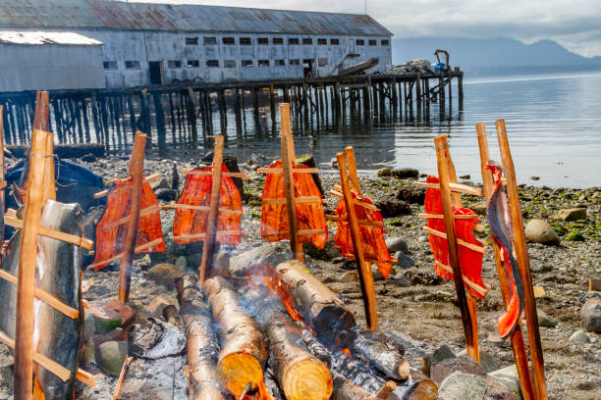
Fish and marine resources are integral to our way of life and have sustained our people for generations. We have a strong interest in ensuring that these resources are preserved for present and future generations.

The Fraser Salmon Management Council is a body established under an agreement with 76 First Nations and the Department of Fisheries and Oceans to share jurisdiction and shared decision-making between Indigenous Nations and the DFO. I have served as the ‘Namgis appointed representative on this body from 2014 to the present. My involvement with the Fraser Salmon Management Council, together with my work as a commercial fisherman and seine boat captain has provided considerable experience in fisheries issues affecting our people.
Under my leadership, I would work towards obtaining the support of the ‘Namgis Council to secure more licenses (e.g. halibut, prawn, crab and other species).


I would work towards revitalizing our Gwa’ni River through enhancement, continued lake fertilization and seeking changes to provincial forestry legislation to secure stricter measures to protect creeks where our salmon spawn.

- Housing
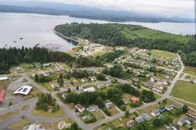
Like most First Nations communities throughout the country, we have chronic housing shortages in our community.
‘Namgis Council and administration have developed a proposal to secure 65 housing units and will be seeking membership approval to borrow funds for this purpose. We will not proceed with any proposals without the consent of ‘Namgis people.
Other solutions are required, as we cannot simply solve our housing shortage through bank financing for individual members as reserve lands cannot be mortgaged. This leaves us dependent on woefully inadequate government funding to address housing shortages in our community.
Under my leadership, in addition to seeking your approval of the proposal to borrow funds to secure 65 housing units, I would seek a mandate from ‘Namgis members to establish a Housing Corporation that would make loans available to members for new home construction.
Similar to conventional mortgages available off-reserve, loans made through the Housing Corporation would be amortized over 25 years so that those members who can afford to pay mortgages and have good credit ratings can apply for loans to build new homes on ‘Namgis reserves at ‘Yalis. With the support of ‘Namgis people, I would pursue partnerships with BC and/or Canada (e.g. through CMHC) to secure operating capital for the Housing Corporation.

- Teamwork and Accountability

Good governance requires a team approach. Decision-making cannot be left in the hands of a few individuals only. The work must be shared by all members of Council and decisions must be made by consensus or by a majority of Council after fulsome and where required, vigorous debate.

Where decisions affect the title and rights of ‘Namgis people, then the team approach must include hereditary Chiefs and ‘Namgis members, whose jurisdiction and collective rights are at issue.
Under my leadership, I will take a team approach to all decisions that affect ‘Namgis people. To ensure that members have greater access to leadership, I will work on securing office space and regular office hours.
- Sports and Recreation


Under my leadership, ‘Namgis Council will continue working towards maintaining our soccer field, making Phase 2 and 3 further improvements to the soccer field, obtaining flood lights and constructing a new field house and concession stand.

Gilakas’la
Donald Victor Isaac

TOGETHER WE CAN – RE-ELECT DONALD VICTOR ISAAC AS ‘NAMGIS CHIEF

